GEOINFOTECH
ELECTION INTELLIGENCE
DATA CENTER
Proposal for the Development of a Centralized Geospatial and Electoral Data Infrastructure
Pilot implementation: Lagos State, Nigeria · Scalable to national and international electoral systems
Full Technical and Delivery Proposal
Prepared by: Geoinfotech
Date: 17 August 2026

Contents
Contents 2
1. Executive Summary 3
2. Background 3
3. Problem Statement 4
4. Aim of the Project 4
5. Objectives of the Project 4
6. Scope of the Project 5
7. Proposed Data Inputs 6
8. Data Sources and Access 7
9. Key Electoral Indicators 8
10. Election Intelligence Data Center Architecture 9
11. Proposed Dashboard Modules 10
12. Electoral Rankings Engine 12
13. Campaign and Operational Map Generation 13
14. Data Mining and Intelligence Unit 14
15. Data Quality, Governance, Security and Compliance 14
16. Proposed Technology Stack 15
17. Expected Outputs 16
18. Expected Benefits 16
19. Project Team and Staffing 16
20. Implementation Phases 17
21. Risks and Assumptions 19
22. Future Development 20
23. Proposed Long-Term Vision 20
24. Success Indicators 20
25. Conclusion 21

1. Executive Summary
The Election Intelligence Data Center (EIDC) is proposed as a centralized geospatial and electoral data infrastructure designed to collect, integrate, analyze, visualize, and disseminate election-related data at multiple administrative and electoral levels.
The initial implementation will focus on Lagos State, integrating historical and current voter-registration and Permanent Voter’s Card (PVC) collection data with a comprehensive geospatial database of polling units, wards, and Local Government Areas (LGAs).
The proposed system will enable users to understand the spatial distribution and evolution of the electorate by comparing voter registration and PVC collection between electoral cycles. It will provide analytical capabilities at LGA, Ward, and Polling Unit levels, allowing users to identify areas with high voter populations, high PVC collection, significant voter growth, low PVC collection rates, and other relevant electoral patterns.
The Data Center will serve as the underlying data and analytics infrastructure, while an interactive Election Intelligence Dashboard will provide a user-friendly interface for exploring the information through maps, charts, rankings, reports, and downloadable campaign/operational maps.
The platform is designed to be scalable beyond Lagos State and Nigeria. Its database architecture will support different electoral hierarchies and datasets, allowing the system to evolve into a broader global Election Intelligence Platform.
The platform is anchored to the Lagos electoral structure - 20 LGAs, 245 wards (Registration Areas) and 13,325 polling units - into which official INEC register figures, PVC-collection returns and the polling-unit geodatabase load directly, without redesign.

2. Background
Election management and electoral planning increasingly depend on accurate, timely, and spatially referenced data.
Traditional election datasets are frequently presented as tables or spreadsheets, making it difficult to understand the geographic distribution of voters and the relationship between electoral statistics and physical locations.
For effective electoral planning, however, it is important to answer questions such as:
- Where are the largest concentrations of registered voters?
- Where are the highest numbers of PVCs collected?
- Which LGAs and wards experienced the greatest growth in registered voters?
- Which polling units have the highest electorate?
- Where are PVC collection rates high or low?
- How has the electoral landscape changed between electoral cycles?
- Which wards contain the largest concentrations of polling units and voters?
- How can standardized maps be generated for individual wards and LGAs?
- How can electoral data be transformed into actionable geospatial intelligence?
The proposed Election Intelligence Data Center addresses these challenges by bringing electoral statistics and geographic information into a single integrated environment.

3. Problem Statement
Electoral data is often distributed across different sources, formats, administrative levels, and time periods. This creates difficulties in performing comprehensive spatial analysis and making direct comparisons between electoral cycles.
A spreadsheet containing registered voters may provide the numerical picture, while a separate polling-unit dataset provides geographic locations. Without integrating these datasets, it is difficult to determine how voter populations are distributed spatially.
Similarly, PVC collection figures may show the number of collected cards without immediately revealing:
- the geographic areas where collection is strongest;
- areas with significant numbers of uncollected PVCs;
- changes in voter population over time;
- variations between wards;
- polling units with unusually high voter concentrations.
The absence of an integrated geospatial intelligence environment therefore limits the ability of analysts, election planners, researchers, and authorized campaign/field teams to efficiently interpret electoral information.
The Election Intelligence Data Center is proposed to address this gap by establishing a structured electoral geodatabase and analytical platform capable of transforming raw electoral data into actionable geographic intelligence.

4. Aim of the Project
The primary aim of the project is:
To develop a centralized geospatial Election Intelligence Data Center that integrates electoral statistics, PVC collection data, polling-unit geospatial information, and historical election datasets to provide comprehensive spatial analysis, visualization, reporting, and decision-support capabilities at LGA, Ward, and Polling Unit levels.

5. Objectives of the Project
The specific objectives are to:
- Electoral Data Integration - To collect, clean, standardize, and integrate voter-registration and PVC-collection datasets for different electoral cycles.
- Geospatial Database Development - To develop a centralized PostgreSQL/PostGIS geospatial database containing the geographic and administrative structure of polling units, wards, and LGAs.
- Electoral Hierarchy Integration - To establish reliable relationships between State → LGA → Ward → Polling Unit so that electoral statistics can be aggregated and analyzed consistently at different geographic levels.
- Temporal Electoral Analysis - To compare electoral data across different years, initially focusing on the comparison between 2022 and 2026 datasets.
- Voter Population Analysis - To determine the spatial distribution of registered voters and identify areas with the highest concentrations of registered voters.
- PVC Collection Analysis - To determine the number, distribution, and collection rates of PVCs across LGAs, wards, and polling units.
- Electoral Change Detection - To identify areas experiencing significant changes in registered voters, PVC collection, and other available electoral indicators between electoral cycles.
- Spatial Visualization - To develop interactive maps capable of visualizing electoral indicators at LGA, Ward, and Polling Unit levels.
- Automated Map Production - To develop a map-generation system capable of producing standardized maps for individual wards, LGAs, and other electoral areas.
- Reporting - To generate automated electoral intelligence reports, statistical summaries, maps, and downloadable datasets.
- Decision Support - To provide a centralized analytical environment that supports evidence-based electoral planning, research, field operations, monitoring, and other authorized activities.
- Scalability - To design the platform architecture so that it can subsequently support additional Nigerian states and electoral systems in other countries.

5.9 Electoral Rankings
To provide automated rankings of LGAs, wards, and polling units based on indicators such as:
- Total registered voters;
- Total PVCs collected;
- PVC collection rate;
- Registered-voter growth;
- PVC growth;
- Historical turnout, where available;
- Other approved electoral indicators.

6. Scope of the Project
The initial phase of the project will focus on Lagos State. The scope will include three principal geographic levels:

Level 1 - Local Government Area
Analysis will include:
- Number of wards;
- Number of polling units;
- Registered voters;
- PVCs collected;
- PVC collection rate;
- Voter growth;
- PVC growth;
- Other approved electoral indicators.

Level 2 - Ward
The system will provide detailed analysis of individual wards, including:
- Registered voters;
- PVCs collected;
- PVC collection rate;
- Number of polling units;
- Voter growth;
- PVC growth;
- Spatial distribution of polling units;
- Historical election indicators where available.

Level 3 - Polling Unit
Each polling unit will have an individual spatial record containing:
- Polling Unit ID/code;
- Polling Unit name;
- Coordinates;
- Ward;
- LGA;
- Registered voters by year;
- PVCs collected by year;
- PVC collection rate;
- Change indicators;
- Historical election information where available.

7. Proposed Data Inputs
The initial system will utilize the following datasets.

7.1 2022 Electoral Dataset
- Registered voters for 2022;
- PVCs collected for 2022;
- PVCs uncollected, where derivable;
- Relevant administrative identifiers.

7.2 2026 Electoral Dataset
- Registered voters for 2026;
- PVCs collected for 2026;
- PVCs uncollected, where derivable;
- Relevant administrative identifiers.

7.3 Polling Unit Geospatial Database
A spatial database containing:
- Polling Unit locations;
- Polling Unit identifiers;
- Ward boundaries/relationships;
- LGA boundaries/relationships;
- Geographic coordinates;
- Administrative hierarchy.

7.4 Historical Election Results
Where available and appropriately sourced, historical election results may be incorporated to support:
- Turnout analysis;
- Votes cast;
- Valid votes;
- Rejected votes;
- Candidate/party performance;
- Historical electoral comparisons.
This component can be introduced as a subsequent phase.

8. Data Sources and Access
✦ New in this version
Because the entire platform depends on obtaining electoral data at the correct level of granularity, this section names the intended source, the level at which each dataset is realistically available, the access route, and the principal access risk. The most sensitive dependency is polling-unit-level PVC-collection data, which is not always released publicly and may require a formal request.
Dataset | Primary source | Level available | Access route
Registered voters (2022 / 2026) | INEC - National Register of Voters / Continuous Voter Registration | LGA, Ward, PU | Published register data; formal data request
PVCs collected (2022 / 2026) | INEC | State and LGA public; Ward/PU on request | Official request / FOI Act 2011; data-sharing MoU
Polling-unit locations and codes | INEC Polling Unit data; GRID3 Nigeria; OpenStreetMap | Point (coordinates) | Open datasets + field verification
Ward and LGA boundaries | INEC / LASIEC / GRID3 / OSM | Polygon | Open geospatial datasets
Historical election results | INEC IReV portal; INEC result sheets | Polling Unit | Public portal extraction (subsequent phase)

8.1 Access strategy
- Formal engagement: a data-request or memorandum of understanding with INEC (and LASIEC for Lagos local-government electoral data) is pursued at project inception under the Freedom of Information Act (2011).
- Layered sourcing: open datasets (GRID3, OpenStreetMap) seed the polling-unit and boundary layers immediately, so development is not blocked while official requests are processed.
- Field verification: coordinates and identifiers are validated against ground truth by the GIS team where discrepancies appear.

8.2 Fallback if PU-level collection data is unavailable
If polling-unit PVC-collection figures cannot be obtained for a cycle, the platform degrades gracefully: analysis and mapping proceed at the finest level for which data exists (typically Ward or LGA), and polling-unit records still carry geography and registered-voter counts. The architecture treats data granularity as a property of each dataset, so partial data never blocks the system.

8.3 Note on the 2026 dataset
The 2026 dataset is defined as the most recent register and PVC-collection snapshot available at the time of build (drawn from INEC’s continuous voter registration). Where a 2026 figure is not yet published for a given field, the system loads the latest available cycle and clearly labels its date, so no comparison is made against missing data.

9. Key Electoral Indicators
The platform will calculate a number of derived indicators.

9.1 PVC Collection Rate
PVC Collection Rate = PVCs Collected ÷ Registered Voters × 100
This will allow comparison between areas with different electorate sizes.

9.2 Uncollected PVCs
Uncollected PVCs = Registered Voters − PVCs Collected
This provides an indication of the number of registered voters without a collected PVC within the available dataset.

9.3 Registered Voter Growth
Voter Growth = Registered Voters 2026 − Registered Voters 2022
The system will also calculate percentage growth.

9.4 PVC Growth
PVC Growth = PVCs Collected 2026 − PVCs Collected 2022
This will identify areas experiencing increases or decreases in PVC collection.

9.5 Collection Rate Change
The system will compare the PVC collection rate between electoral cycles to identify areas where collection efficiency has increased or decreased.

9.6 Electoral Change Index
A composite indicator may subsequently be developed to summarize changes across multiple electoral variables. The index may incorporate:
- Registered-voter growth;
- PVC growth;
- PVC collection rate;
- Change in PVC collection rate;
- Historical turnout, where available.
The methodology for the index will be documented and configurable to ensure transparency.

9.7 Illustrative statewide picture (sample data)
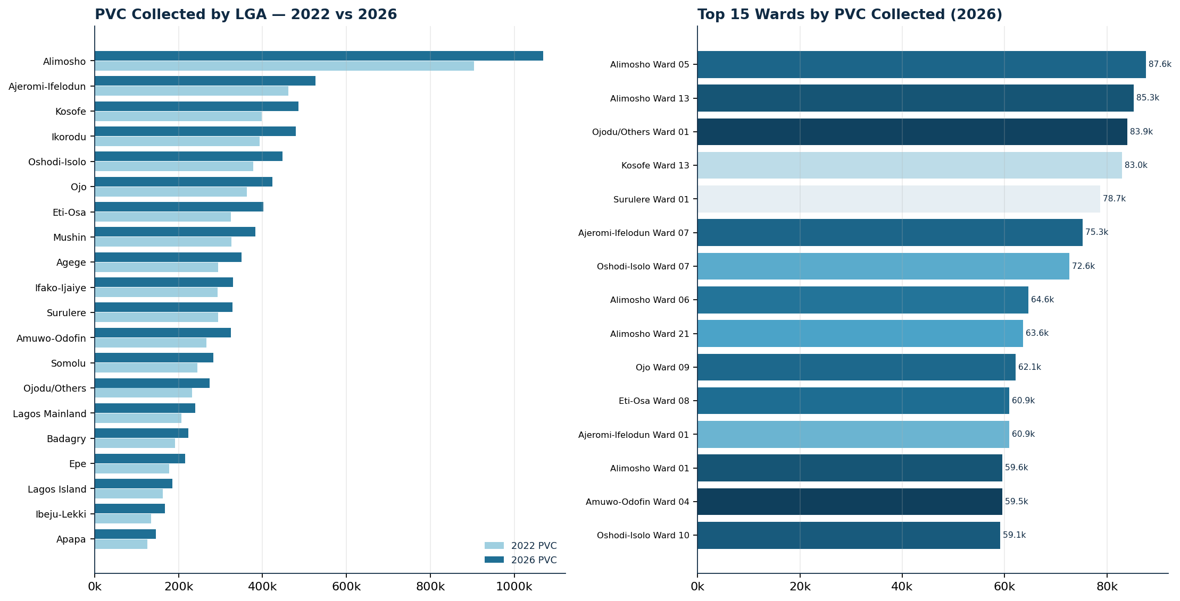
PVC collected by LGA (2022 vs 2026) and the top 15 wards by 2026 collection - sample data.

10. Election Intelligence Data Center Architecture
The proposed architecture will consist of four major components:

10.1 Data Layer - PostgreSQL + PostGIS
Responsible for:
- Electoral data storage;
- Spatial data storage;
- Administrative boundaries;
- Polling-unit geometry;
- Temporal datasets;
- Data relationships;
- Spatial queries.

10.2 Processing and Analytics Layer
Responsible for:
- Data cleaning;
- Data validation;
- Spatial joins;
- Aggregation;
- Statistical calculations;
- Change detection;
- Rankings;
- Spatial analysis.

10.3 API Layer
The API will provide controlled access to the underlying data and analytical services. Potential services include:
- LGA data;
- Ward data;
- Polling Unit data;
- Voter statistics;
- PVC statistics;
- Rankings;
- Spatial layers;
- Analytical indicators;
- Report generation.

10.4 Presentation Layer
The Election Intelligence Dashboard will provide:
- Interactive maps;
- Charts;
- Tables;
- KPI cards;
- Rankings;
- Reports;
- Data filters;
- Map exports.

11. Proposed Dashboard Modules
The Election Intelligence Dashboard is the user-facing entry point to the platform. From a single landing page, users move into the core intelligence modules described below.
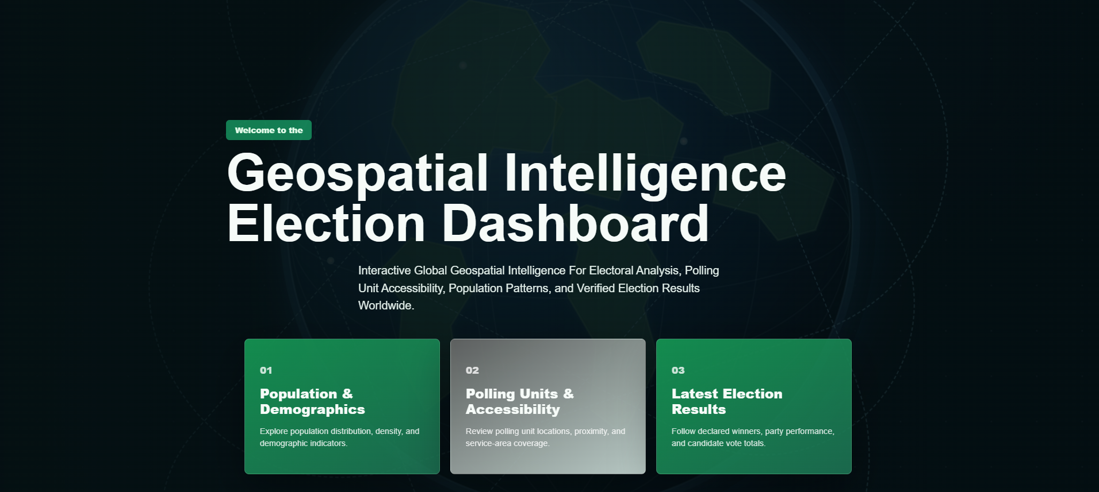
Prototype interface - the Geospatial Intelligence Election Dashboard landing page. Its three entry cards (Population and Demographics; Polling Units and Accessibility; Latest Election Results) correspond directly to the dashboard modules detailed in this section.

11.1 Command Center
The primary dashboard will display high-level electoral statistics. Key indicators will include:
- Total registered voters;
- Total PVCs collected;
- PVC collection rate;
- Total polling units;
- Total wards;
- Total LGAs;
- Registered-voter growth;
- PVC growth.

11.2 Electoral Intelligence Map
The interactive map will serve as the primary visualization interface. Users will be able to switch between different thematic layers. Potential layers include:
- Registered voters;
- PVCs collected;
- PVC collection rate;
- Uncollected PVCs;
- Registered-voter growth;
- PVC growth;
- Electoral change;
- Historical turnout;
- Historical election results.

11.3 LGA Intelligence
The LGA module will allow users to compare all LGAs using configurable indicators. Example (illustrative):
Indicator | Value
Registered Voters | 420,000
PVCs Collected | 370,000
Collection Rate | 88.1%
Wards | 10
Polling Units | 500
Voter Growth | +12.4%

11.4 Ward Intelligence
Users will be able to select an LGA and drill down to its wards. Each ward will have:
- Summary statistics;
- Interactive map;
- Polling-unit list;
- Charts;
- Rankings;
- Historical comparison;
- Exportable report.

11.5 Polling Unit Intelligence
The Polling Unit Intelligence module will provide detailed information for individual polling units. Users will be able to view:
- Location;
- Ward;
- LGA;
- Registered voters;
- PVCs collected;
- Collection rate;
- Change from previous cycle;
- Historical election information where available.
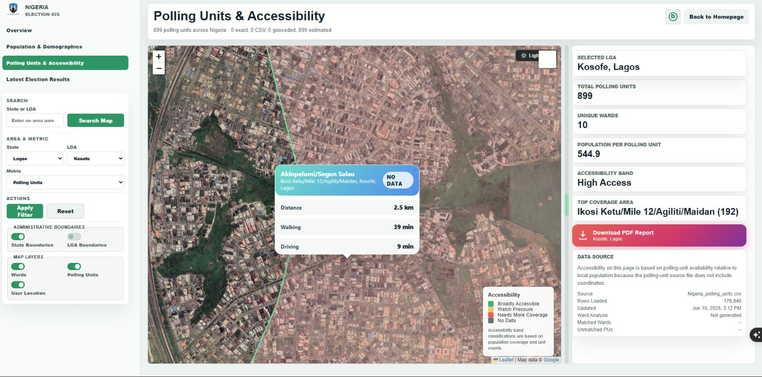
Prototype interface - the Polling Units and Accessibility view, showing an LGA drill-down (Kosofe, Lagos: 899 polling units, 10 wards, ~545 population per unit), a selected polling unit with distance, walking and driving time, accessibility banding, and a one-click PDF report.

12. Electoral Rankings Engine
A dedicated rankings engine will allow users to identify areas based on different indicators.
- Highest Registered Voters - Rank LGAs, wards, and polling units.
- Highest PVCs Collected - Rank LGAs, wards, and polling units.
- Highest PVC Collection Rate - Identify areas with the highest proportion of collected PVCs.
- Highest Voter Growth - Identify areas with the greatest increase in registered voters.
- Highest PVC Growth - Identify areas with the greatest increase in collected PVCs.
- Highest Uncollected PVCs - Identify areas with the largest absolute number of uncollected PVCs.
The ranking methodology will clearly distinguish between absolute counts and percentage indicators.

13. Campaign and Operational Map Generation
The system will include an automated map-generation capability for authorized users. A user will be able to select:
State → LGA → Ward → Map Type → Year
and generate a standardized map. Ward maps may contain:
- Ward boundary;
- Polling Unit locations;
- Polling Unit identifiers;
- Major roads;
- Settlements/landmarks where available;
- LGA boundary;
- Statistical summary;
- Legend;
- North arrow;
- Scale bar;
- Data source;
- Date of production.
The system will support batch generation of maps for multiple wards. This will eliminate the need to manually create individual ward maps.
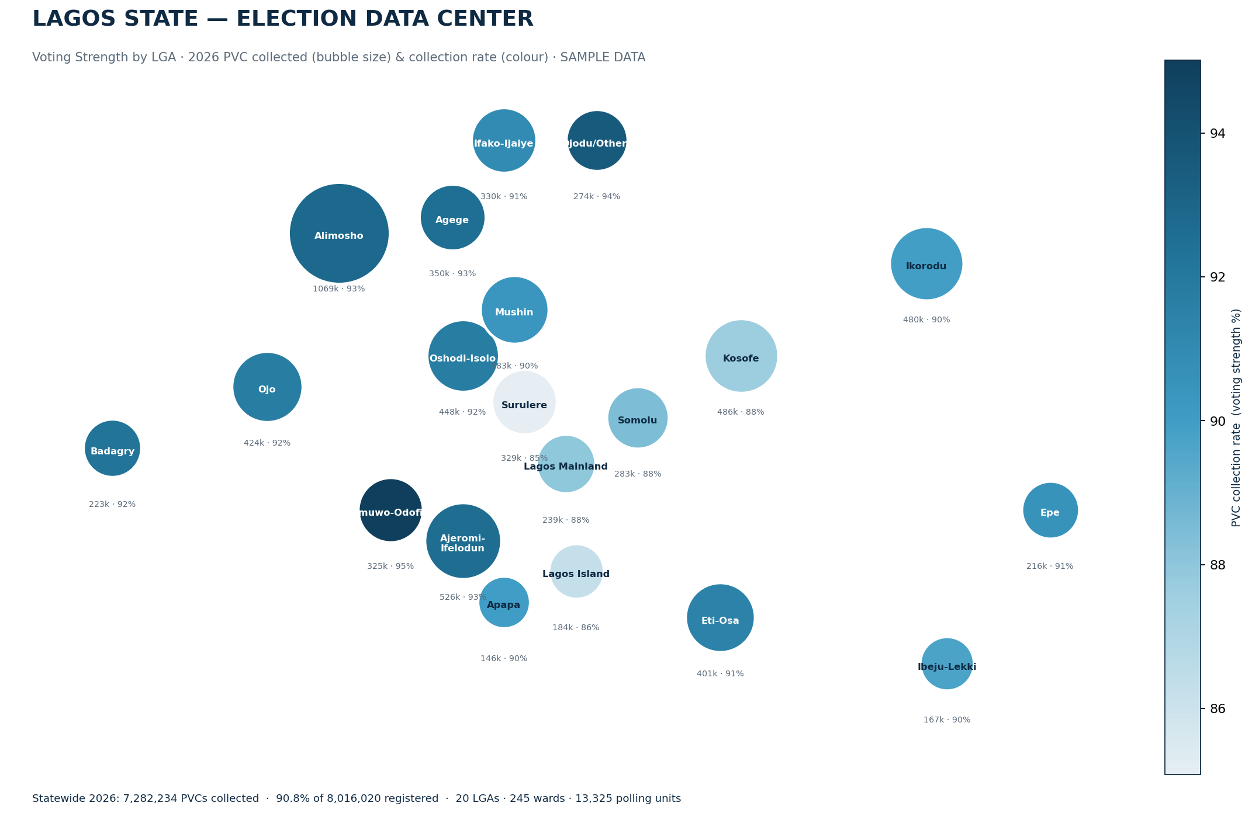
Prototype statewide voting-strength output - bubble size = PVCs collected, colour = collection rate (sample data). A companion Ward Campaign Map Pack renders every one of the 245 wards.

14. Data Mining and Intelligence Unit
A dedicated Electoral Data and Intelligence Unit can operate alongside the Data Center. Its responsibilities will include:

Data Acquisition
- Electoral datasets;
- Polling Unit datasets;
- Administrative boundaries;
- Historical election data;
- Population and demographic datasets where appropriate.

Data Management
- Data cleaning;
- Validation;
- Standardization;
- Version control;
- Metadata management.

GIS Analysis
- Spatial aggregation;
- Density analysis;
- Change detection;
- Hotspot analysis;
- Accessibility analysis;
- Electoral geography analysis.

Intelligence Production
- LGA intelligence reports;
- Ward intelligence reports;
- Polling Unit summaries;
- Electoral change reports;
- Map atlases;
- Statistical dashboards.

15. Data Quality, Governance, Security and Compliance
Data quality will be a fundamental component of the project. The system will establish a unique identifier for each polling unit to ensure that electoral statistics and geographic information remain correctly linked.
The database will maintain a full metadata trail for every dataset:
- Data source;
- Dataset date;
- Election cycle;
- Processing status;
- Validation status;
- Update history;
- Metadata.
This will make it possible to trace where each dataset originated and when it was last updated.

15.1 Legal and regulatory compliance
- Nigeria Data Protection Act (2023): the platform processes aggregate electoral counts, not personal voter records; where any personal data is handled it is done lawfully, minimally, and in line with the NDPA and Nigeria Data Protection Commission guidance.
- Electoral Act (2022): all data use aligns with the legal framework governing electoral information and its permissible uses.
- Freedom of Information Act (2011): used as the formal basis for requesting public electoral datasets.

15.2 Ethical use and dual-use safeguards
- Aggregation, not surveillance: the system works with counts and rates at unit level - it measures collection and strength, it does not profile individual voters.
- Legitimate purposes only: the platform supports electoral planning, research, monitoring, voter education and lawful, authorized campaign field operations; an acceptable-use policy governs access.
- Transparency: every figure traces to a dated, loaded source, so any map or ranking can be reproduced and defended.

15.3 Security controls
- Role-based access control separating read-only, analyst/editor and administrator roles.
- Encryption in transit (HTTPS/TLS) and at rest for the database and backups.
- Audit logging of who viewed, queried or exported which data.
- Environment separation, automated backups, and vulnerability management as standard operational practice.

15.4 Data ownership, retention and handover
Ownership of loaded datasets and produced outputs is agreed with the commissioning party at inception. Retention periods, an update cadence for each cycle, and a maintenance/handover plan are documented so the system remains current and accountable after deployment.

16. Proposed Technology Stack
The recommended technology stack is:
Layer | Components
Database | PostgreSQL · PostGIS
GIS | QGIS · GDAL/OGR · PostGIS spatial functions
Backend | Python · FastAPI or Django
Frontend | React / Next.js
Mapping | MapLibre GL JS or Mapbox · OpenStreetMap basemaps · PostGIS vector services
Analytics | Python · Pandas · GeoPandas · NumPy · Scikit-learn (where appropriate)
Infrastructure | Linux server · Docker · Nginx · HTTPS · Automated backups

The final technology selection may be adjusted according to deployment requirements. The stack is predominantly open-source, which keeps software-licensing cost minimal.

17. Expected Outputs
The project is expected to deliver:
- A centralized electoral geospatial database.
- A structured Lagos State polling-unit database.
- Integrated 2022 and 2026 voter/PVC datasets.
- LGA-level electoral intelligence.
- Ward-level electoral intelligence.
- Polling-unit-level electoral intelligence.
- Interactive electoral maps.
- Electoral rankings.
- Voter-growth analysis.
- PVC-collection analysis.
- Electoral change analysis.
- Automated ward map generation.
- Downloadable electoral reports.
- Downloadable geospatial datasets.
- An Election Intelligence Dashboard.
- A scalable Election Intelligence Data Center architecture.

18. Expected Benefits
- Improved Data Accessibility - Electoral data will be available through a centralized platform rather than scattered across multiple spreadsheets and files.
- Improved Spatial Understanding - Users will be able to understand electoral statistics geographically.
- Faster Decision-Making - Complex datasets can be converted into dashboards, maps, rankings, and reports.
- Improved Electoral Planning - The platform can support authorized electoral planning, field logistics, monitoring, research, and voter-education activities.
- Historical Comparison - Users will be able to compare electoral conditions across different election cycles.
- Automated Cartography - Large numbers of ward and LGA maps can be generated automatically.
- Scalability - The architecture can support additional states and countries.

19. Project Team and Staffing
Delivery is led by Geoinfotech. The indicative core team below can be scaled to the agreed scope and timeline; several roles may be combined for a lean pilot.
Role | Core responsibilities | Indicative effort
Project Lead / GIS Manager | Overall delivery, stakeholder and data-access engagement, QA sign-off | Part-time, full project
GIS Analyst (×1–2) | Geodatabase build, spatial joins, boundary/PU validation, map templates | Full-time, Phases 2–6
Database / Backend Engineer | PostGIS schema, ETL pipelines, API, security controls | Full-time, Phases 2–5
Frontend Developer | Dashboard modules, interactive maps, exports | Full-time, Phases 5–6
Data Analyst | Indicator logic, rankings, change detection, reports | Full-time, Phases 3–4
Data Quality / QA Officer | Validation, provenance, metadata, acceptance testing | Part-time, Phases 2–8
Project Coordinator | Scheduling, documentation, training logistics | Part-time, full project

20. Implementation Phases
The project is delivered in eight phases. Indicative durations assume the lean core team above; phases overlap where dependencies allow, so usable outputs appear before the platform is feature-complete.
Phase | Focus | Key deliverable
1 | Requirements and Data Assessment | Requirements and technical specification
2 | Geospatial Database Development | Lagos Electoral Geospatial Database
3 | Electoral Data Integration | Integrated electoral database
4 | Analytics Engine | Electoral Analytics Engine
5 | Interactive Dashboard | Election Intelligence Dashboard
6 | Automated Map Production | Automated Electoral Mapping System
7 | Historical Election Intelligence | Historical Election Intelligence Module
8 | Deployment and Training | Production EIDC + trained users

20.1 Phase activities and deliverables

Phase 1 - Requirements and Data Assessment
- Stakeholder consultation;
- Requirements gathering;
- Dataset inventory;
- Data-source assessment;
- Data-quality assessment;
- System architecture design.
Deliverable: Project requirements and technical specification.

Phase 2 - Geospatial Database Development
- PostgreSQL/PostGIS deployment;
- Administrative boundary loading;
- Polling-unit database development;
- Unique identifier establishment;
- Spatial relationships;
- Database schema development.
Deliverable: Lagos Electoral Geospatial Database.

Phase 3 - Electoral Data Integration
- 2022 dataset integration;
- 2026 dataset integration;
- Data cleaning;
- Data standardization;
- Spatial joins;
- Data validation.
Deliverable: Integrated electoral database.

Phase 4 - Analytics Engine
- Voter totals;
- PVC totals;
- Collection rates;
- Voter growth;
- PVC growth;
- Rankings;
- Electoral change indicators.
Deliverable: Electoral Analytics Engine.

Phase 5 - Interactive Dashboard
- Command Center;
- Electoral Map;
- LGA Intelligence;
- Ward Intelligence;
- Polling Unit Intelligence;
- Rankings;
- Reports.
Deliverable: Election Intelligence Dashboard.

Phase 6 - Automated Map Production
- Ward map templates;
- LGA map templates;
- Polling-unit maps;
- Batch map generation;
- PDF/PNG export.
Deliverable: Automated Electoral Mapping System.

Phase 7 - Historical Election Intelligence
- Turnout analysis;
- Historical comparisons;
- Vote distribution analysis;
- Electoral volatility indicators.
Deliverable: Historical Election Intelligence Module.

Phase 8 - Deployment and Training
- Production deployment;
- Security configuration;
- User management;
- Documentation;
- Staff training;
- System handover.
Deliverable: Production Election Intelligence Data Center.

21. Risks and Assumptions

21.1 Key risks and mitigation
Risk | Likelihood | Impact | Mitigation
Polling-unit-level PVC data not released | Medium | High | Formal FOI/MoU request; graceful fallback to Ward/LGA level; open-data seeding
2026 register/PVC data not yet available | Medium | Medium | Load latest published cycle; date-label all figures; phase build to data release
Boundary / PU location inaccuracies | Medium | Medium | Cross-check GRID3, OSM and INEC; field verification; QA sign-off
Data-protection / legal exposure | Low | High | NDPA (2023) compliance; aggregate-only processing; audit logging
Misuse for individual profiling | Low | High | Acceptable-use policy; role-based access; no personal-record storage
Scope creep / timeline slip | Medium | Medium | Phased delivery; fixed per-phase deliverables; change control
Key-staff availability | Medium | Medium | Cross-training; combinable roles; documented processes
Hosting / data loss | Low | High | Automated encrypted backups; environment separation; recovery testing

21.2 Assumptions
- Official electoral datasets can be obtained at, or aggregated to, the levels required;
- INEC / LASIEC and other sources permit the intended, lawful use of their data;
- Polling-unit identifiers are stable enough to link statistics to geography across cycles;
- The commissioning party provides timely access, decisions and approvals during delivery;
- The pilot scope remains Lagos State, with expansion treated as separate subsequent phases.

22. Future Development
Following successful implementation in Lagos State, the platform can be expanded to cover:

Nigeria
- All 36 states;
- Federal Capital Territory;
- National electoral datasets.

International Expansion
The platform can subsequently support other countries by adapting its geographic and electoral hierarchy. For example:
- Nigeria: State → LGA → Ward → Polling Unit
- Another country: Country → Region → District → Constituency → Polling Station
The underlying system will therefore be designed around a flexible electoral geography model.

23. Proposed Long-Term Vision
The long-term vision is to establish the Election Intelligence Data Center as a comprehensive electoral geospatial intelligence infrastructure.
The platform should eventually become capable of answering questions such as: Where is the electorate? How large is it? How has it changed? Where are voters concentrated? How are PVCs distributed? How does participation vary spatially? How has electoral geography changed between election cycles? Where are polling units located? What are the spatial characteristics of each electoral area? How can this information be converted into standardized maps, reports, and operational intelligence?
The system will therefore evolve from a simple visualization platform into a temporal, spatial, analytical electoral data infrastructure.

24. Success Indicators
The success of the initial implementation will be measured by the ability of the system to:
- Integrate the available 2022 and 2026 electoral datasets;
- Correctly associate electoral records with polling units;
- Aggregate data to Ward and LGA levels;
- Calculate key electoral indicators automatically;
- Display electoral information on interactive maps;
- Rank LGAs, wards, and polling units;
- Compare electoral data across years;
- Generate standardized ward maps;
- Produce analytical reports;
- Maintain data provenance and update history;
- Provide a scalable architecture for future electoral datasets.

25. Conclusion
The proposed Election Intelligence Data Center represents a strategic approach to transforming electoral data into structured, spatially enabled intelligence.
By integrating voter-registration statistics, PVC collection data, polling-unit geospatial information, historical election data, and analytical tools, the platform will provide a comprehensive view of electoral geography from the LGA level down to individual polling units.
The initial Lagos State implementation will serve as a pilot and technical foundation for a larger Election Intelligence Platform. Rather than functioning merely as a dashboard, the proposed system will establish a centralized electoral data infrastructure, geospatial intelligence engine, analytical environment, and automated mapping platform.
Its scalable architecture will allow the project to expand geographically and temporally, supporting additional Nigerian states, future election cycles, and eventually electoral systems in other countries.
The ultimate goal is to create a reliable and continuously evolving Election Intelligence Data Center capable of turning complex electoral datasets into accessible maps, statistics, reports, and evidence-based intelligence for authorized users and legitimate electoral purposes.
Geoinfotech · Election Intelligence Data Center · Proposal v2.0 · Quantitative figures are sample/illustrative pending official INEC and geospatial data load.

